***Image Inpainting using Deep Generative Modelling***

Balagouda nirwani

DEPT OF ELECTRONICS AND COMMUNICATION

KLS GOGTE INSTITUE OF TECHNOLOGY

BELGAUM, KARNATAKA, INDIA

***Abstract:***

***Image inpainting is a fundamental computer vision task that aims to fill in missing or corrupted regions in an image while preserving its overall visual coherence and semantic information. Traditional approaches for image inpainting relied on handcrafted algorithms or patch-based methods, which often produced unsatisfactory results. However, the recent advancements in deep generative modelling have revolutionized the field of image inpainting. This paper provides an in-depth exploration of image inpainting techniques using deep generative modelling, discussing popular models, training strategies, evaluation metrics, challenges, and future directions. We also examine the applications and impact of deep generative models in image inpainting.***

**1. Introduction**

1.1 Motivation

The digital era has created a need for effective image inpainting techniques in various domains, such as image restoration, editing, and privacy preservation. Deep generative models have shown tremendous potential in generating high-quality inpainting results, motivating further exploration in this field.

1.2 Objectives

The main objective of this paper is to provide a comprehensive and detailed overview of image inpainting using deep generative modelling techniques. This includes discussing popular models, training strategies, evaluation metrics, challenges, and future directions.

1.3 Structure of the Paper

The paper is structured to cover different aspects of image inpainting using deep generative modelling. It begins with an introduction, followed by sections on deep generative models, training strategies, evaluation metrics, challenges, and future directions. The paper concludes by discussing the applications and impact of deep generative models in image inpainting.

**2. Image Inpainting Overview**

2.1 Definition and Applications

This section provides a clear definition of image inpainting and highlights its diverse applications in fields such as image restoration, object removal, privacy preservation, and digital entertainment. It emphasizes the importance of inpainting in maintaining visual coherence and semantic information in images.

2.2 Challenges in Image Inpainting

Image inpainting poses several challenges, including effectively handling large and structurally complex inpainting regions, preserving fine details, addressing bias and unwanted artefacts, and achieving real-time performance. This section discusses these challenges, emphasizing their impact on the quality of inpainting results.

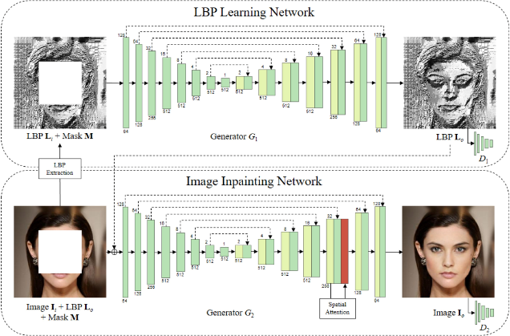

**3. Deep Generative Models for Image Inpainting**

3.1 Generative Adversarial Networks (GANs)

Generative Adversarial Networks (GANs) have garnered significant attention in image inpainting due to their ability to generate realistic and visually appealing results. This section provides a comprehensive explanation of GANs, their architecture, and training process for image inpainting. It explores popular GAN-based inpainting models, including Context Encoders, PatchGAN, and Boundary Equilibrium GAN (BEGAN).

3.2 Variational Autoencoders (VAEs)

Variational Autoencoders (VAEs) offer an alternative approach to image inpainting, focusing on learning a probabilistic latent space representation of images. This section delves into VAE-based inpainting methods, discussing models such as VAE-GAN, Adversarial Variational Bayes (AVB), and Conditional VAE (CVAE).

3.3 Autoregressive Models

Autoregressive models generate image pixels sequentially, capturing dependencies between neighboring pixels. This section explores the application of autoregressive models for image inpainting, examining models like PixelCNN and PixelRNN. It discusses the strengths and limitations of autoregressive models in the context of inpainting.

3.4 Hybrid Approaches

Hybrid approaches combine multiple generative models to leverage their respective strengths. This section investigates the integration of GANs, VAEs, and autoregressive models in image inpainting, discussing techniques such as GAN + VAE, VQ-VAE-2

, and Glow.

**4. Training Strategies for Image Inpainting**

4.1 Partial Convolution-based Approaches

Partial convolution-based methods adapt the standard convolution operation to handle masked regions effectively. This section explains how partial convolutions can be utilized for image inpainting, discussing techniques like Partial Convolutional Neural Network (PCNN) and Shift-Net.

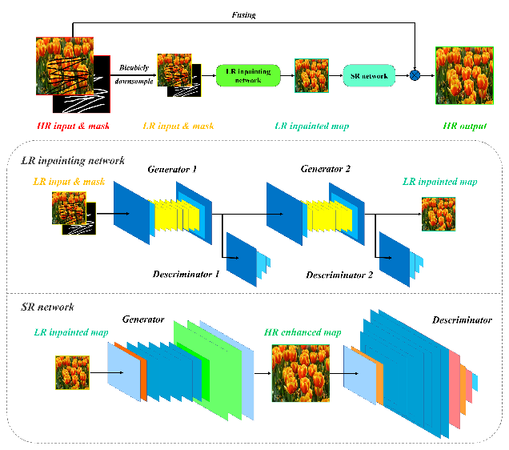

4.2 Context Encoders

Context encoders treat image inpainting as an image-to-image translation task. This section explores the training strategies employed by context encoders, including the use of adversarial training, perceptual losses, and identity losses.

4.3 Patch-based Methods

Patch-based approaches divide the image into smaller patches and inpaint them individually. This section discusses patch-based methods, such as exemplar-based inpainting, patch match, and PatchGAN, highlighting their advantages and limitations.

4.4 Self-Attention Mechanisms

Self-attention mechanisms enable models to capture long-range dependencies efficiently. This section examines the use of self-attention mechanisms in image inpainting, including techniques like non-local means, self-attention GANs, and self-attention generative inpainting network (SAGAN).

4.5 Perceptual Losses

Perceptual losses utilize pre-trained networks to measure perceptual similarity between the inpainted image and the ground truth. This section explores the concept of perceptual losses and their integration into deep generative models for image inpainting.

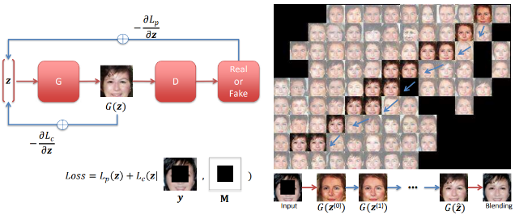

**5. Evaluation Metrics for Image Inpainting**

5.1 Pixel-level Metrics

Pixel-level metrics assess the quality of inpainting at the pixel level, including metrics like peak signal-to-noise ratio (PSNR) and structural similarity index (SSIM). This section explains these metrics and their applicability to image inpainting evaluation.

5.2 Perceptual Metrics

Perceptual metrics evaluate the visual quality of inpainting results by measuring perceptual similarity to the ground truth. This section discusses metrics like feature similarity index (FSIM) and perceptual similarity metric (PSIM).

5.3 User Studies

User studies involve subjective assessments by human observers to evaluate the visual quality of inpainting results. This section explores the design and implementation of user studies for image inpainting evaluation.

**6. Challenges and Future Directions**

6.1 Handling Large and Structurally Complex Inpainting Regions

Addressing the challenges of inpainting large and structurally complex regions requires advanced techniques such as hierarchical inpainting and attention mechanisms. This section discusses ongoing research efforts in this area.

6.2 Improving Long-range Dependency Modelling

Capturing long-range dependencies remains a challenge in image inpainting. This section explores strategies such as self-attention, graph convolutions, and recurrent neural networks to improve long-range dependency modelling.

6.3 Addressing Bias and Unwanted Artefacts

Inpainting algorithms can exhibit bias or generate unwanted artefacts. This section discusses methods to mitigate these issues, including adversarial training, explicit regularization, and data augmentation.

6.4 Real-time Inpainting

Achieving real-time performance is crucial for practical applications of image inpainting. This section examines techniques such as network optimization, parallelization, and hardware acceleration to enable real-time inpainting.

6.5 Explainable and Controllable Inpainting

Ensuring explainability and controllability in inpainting algorithms is essential. This section explores approaches such as attention mechanisms, interpretable latent spaces, and interactive inpainting.

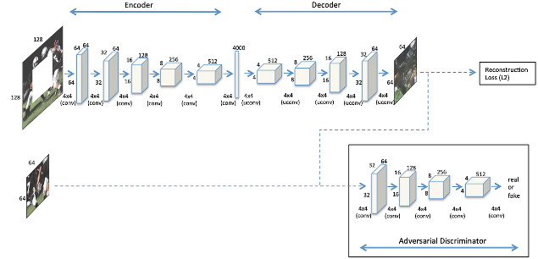

**7. Applications and Impact**

7.1 Restoration of Damaged Images

Deep generative models have shown remarkable capabilities in restoring damaged images, such as old photographs or digitized historical documents. This section discusses the potential impact of deep generative inpainting in image restoration tasks.

7.2 Object Removal and Editing

Deep generative models enable seamless object removal and editing in images,

offering practical applications in areas like content-aware image editing and visual effects. This section explores the implications of deep generative inpainting for object removal and editing tasks.

7.3 Privacy Preservation

Image inpainting can be used for privacy preservation by obscuring sensitive information in images. This section discusses the potential applications and ethical considerations of using deep generative models for privacy preservation.

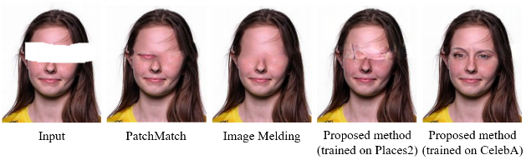

7.4 Digital Entertainment and Visual Effects

Deep generative inpainting techniques have significant implications in the entertainment industry, enabling realistic visual effects, scene completion, and virtual set extension. This section explores the impact of deep generative inpainting in digital entertainment and visual effects.

**8. Conclusion**

This paper provides a comprehensive overview of image inpainting using deep generative modelling techniques. We discussed popular deep generative models, training strategies, evaluation metrics, challenges, and future directions in the field. Additionally, we explored the diverse applications and impact of deep generative models in image inpainting. The advancements in deep generative modelling have revolutionized image inpainting, opening up new possibilities for image restoration, editing, and privacy preservation.

**9. References**

The paper concludes with a list of references cited throughout the paper, providing readers with further resources to explore the topic in depth.